# Appeal of Marked Answers – Lesson 2 Quiz

Dear Professor,

I am writing to request reconsideration of four questions from the Lesson 2 quiz. After reviewing the required text (Moran, Employment Law, 6th ed.) and the Lesson 2 readings, I believe the answers I selected were correct and should not have been marked incorrect. Below, I explain my reasoning for each.

## Q2 – Liability for Employee’s Criminal Acts

Selected Answer: (d) Neither is liable

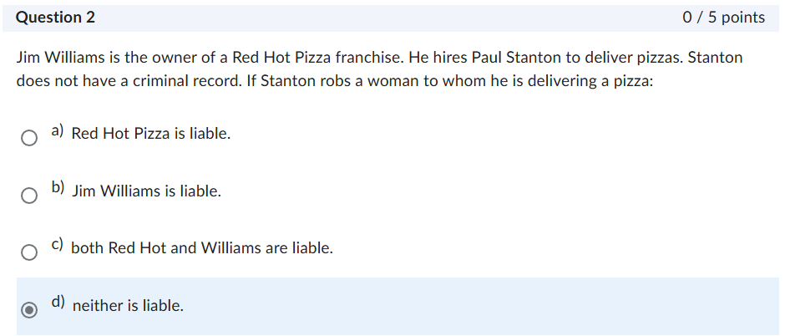

The text explains that employers are liable under respondeat superior only when an employee’s wrongful acts are committed within the scope of employment. The three-part test considers whether the act was of the kind the employee was hired to perform, within authorized time and space limits, and motivated at least in part by serving the employer. Robbery is a personal, intentional crime that does not serve the employer’s business interests.  
  
Case law supports this reasoning. In Stalbosky v. Belew, 205 F.3d 890 (6th Cir. 2000), a pizza delivery driver assaulted a customer during delivery; the court held the employer was not liable because the crime was outside the scope of employment. Since Stanton had no criminal record, negligent hiring also does not apply.  
  
Why my answer is correct: Under these principles, neither Red Hot Pizza nor Jim Williams should be held liable.

## Q9 – Honesty Tests

Selected Answer: (d) Psychological

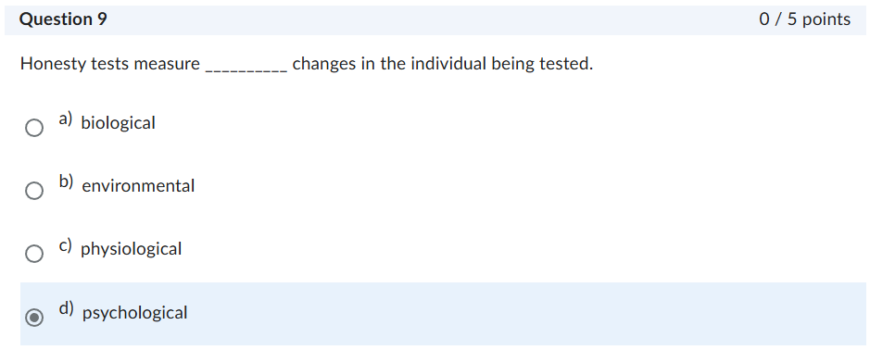

The book distinguishes between polygraphs (physiological) and honesty/integrity tests (psychological). Honesty tests are widely used paper-and-pencil or computerized questionnaires designed to predict counterproductive behavior (such as theft or absenteeism). These are explicitly described in the text as psychological instruments, not physiological measures.  
  
Physiological measures apply only to polygraphs, which are restricted under the Employee Polygraph Protection Act. Since the question referred specifically to “honesty tests,” the accurate categorization is psychological.  
  
Why my answer is correct: The reading materials define honesty tests as psychological, making (d) the most accurate choice.

## Q10 – Reasonable Suspicion Drug Testing

Selected Answer: (c) Is governed by a stricter standard than random testing

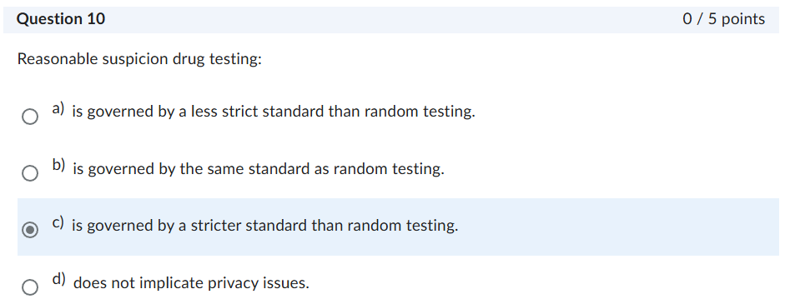

Moran emphasizes that reasonable suspicion testing requires specific, articulable facts that an employee is impaired—observable evidence such as unsafe behavior, slurred speech, or the smell of alcohol or drugs. By contrast, random testing applies with no individualized suspicion.  
  
Because suspicion-based testing intrudes on employee privacy, the courts have held that it must be backed by documented evidence to withstand legal scrutiny (Skinner v. Railway Labor Executives’ Ass’n). That evidentiary threshold makes it a stricter standard than random testing.  
  
Why my answer is correct: My selection aligns with the textbook’s explanation that suspicion testing requires a more rigorous, individualized showing.

## Q19 – Criminal Background Checks

Selected Answer: (b) Permitted upon a showing of job-relatedness

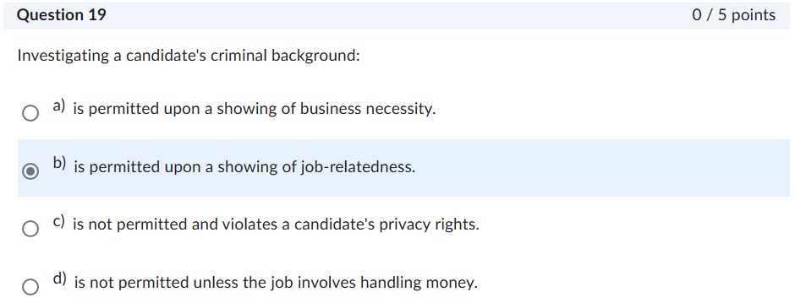

The EEOC’s guidance, cited in the readings, requires that use of criminal records be “job related and consistent with business necessity.” The two standards are inseparable, but the emphasis in both Moran and the EEOC’s “Green factors” analysis (nature of the crime, time elapsed, and relation to the job) is squarely on job-relatedness. Without a showing of job-relatedness, a claim of business necessity cannot stand.  
  
Why my answer is correct: Selecting “job-relatedness” reflects the standard as taught in the text and EEOC guidance, and should be accepted as correct alongside business necessity.

For these reasons, I respectfully request that my answers to Questions 2, 9, 10, and 19 be re-evaluated and considered correct. My selections are consistent with Moran, Employment Law (6th ed.), the Lesson 2 readings, and the governing legal standards.

Thank you for your consideration.

Sincerely,

Javier Silva